

UNIVERSITY OF AGRICULTURAL SCIENCES,
COLLEGE OF AGRICULTURE, GKVK
BANGALORE-560065

EAI421- APPLICATION OF ARTIFICIAL INTELLIGENCE AND
MACHINE LEARNING

PROJECT TITLE:
“ArecaNET” Smart farming by reduction of Cost of Cultivation through
alert system using CNN and Realtime data



Submitted to:
Dr.Kumar Raja
The Course Teacher
Application of AI&ML
COA, GKVK, Bangalore-65.

Submitted by:
Harish B K -AMB2082
Bhagavan G - AMB2032
D.Dhanusha - AMB2068
VI B.Sc.(Hons) Agriculture
COA, GKVK, Bangalore-65

CERTIFICATION

This is to certify that the project report entitled ““ArecaNET” Smart farming by reduction of Cost of Cultivation through alert system using CNN and realtime data”is a bonafide work carried out by Bhagavan G, Harish B.K, D.Danusha bearing ID.No AMB2032, BMB2082, BMB2068, in partial fulfillment of the requirements for the award of the degree in [B.Sc (Hons) Agriculture & B.Sc (Hons) Agri- Business Management] under the course "Application of Artificial Intelligence and Machine Learning in Agriculture.
This work has been carried out under my supervision and guidance during the academic year 2025-2026. The report submitted has not been previously submitted for the award of any degree or diploma in any university.

Guide Signature

Date:-16/04/2026

Place: Bangalore-65

DECLARATION
I hereby declare that the project report entitled "“ArecaNET Smart farming by reduction of Cost of Cultivation through alert system using CNN and realtime data”” is submitted by me in partial fulfillment of the requirements for the award of the degree in B.sc (Hons) Agriculture & B.Sc (Hons) Agri-Business Management] under the course "Application of Artificial Inteligence and Machine Learning in Agriculture."

I further declare that this work is the result of my own efforts and has not been submitted previously to any other university or institution for the award of any degree or diploma.

Bhagavan G AMB2032
Harish B.K AMB2082
D.Danusha AMB2068

Date:-16/04/2026

Place: Bangalore 65

ACKNOWLEDGEMENT

I express my sincere gratitude to my project guide
Dr. Kumar Raja, Professor. for their continuous support, valuable quidance. and encouragement throughout the completion of this proiect
I am also thankful to all the faculty members of the department for their valuable suggestions and assistance during the course of this project

Finally, I would like to express my heartfelt thanks to my family and friends for their constant encouragement and support.

Bhagavan G , Harish B.K , D.Danusha

ABSTRACT

This work presents a secure and intelligent crop advisory system for Arecanut disease prediction by integrating machine learning, data encryption, and visualization techniques. The system leverages a RandomForestClassifier model to analyze key agricultural parameters such as soil type, temperature, humidity, and rainfall for predicting potential plant diseases. To ensure data confidentiality and integrity, the dataset is encrypted using Fernet before storage and decrypted during processing. The proposed framework also incorporates preprocessing techniques like label encoding and dataset splitting using scikit-learn, enabling efficient model training and evaluation. Additionally, the system generates synthetic test inputs using randomization methods to simulate real-world farming conditions and enhance model robustness.
The model outputs not only disease predictions but also corresponding remedial suggestions, thereby assisting farmers in decision-making. Visualization techniques using matplotlib are employed to represent disease distribution and prediction probabilities, making the results more interpretable. Furthermore, the prediction results are securely stored in encrypted format, ensuring end-to-end data protection. The proposed solution demonstrates an effective combination of machine learning and cybersecurity for precision agriculture, offering a scalable and practical approach for real-time crop monitoring and advisory systems.

Keywords: Arecanut, Disease Prediction, Machine Learning, Data Encryption, Random Forest, Secure Agriculture, Precision Farming, Data Visualization, Cryptography, Predictive Analytics.

TABLE OF CONTENTS
S No | Topic | Page No
1 | Introduction | 9
2 | Objective | 10
3 | Review of Literarture | 11 to 14
4 | Problem statement | 15
5 | Dataset Description | 16 to 18
6 | Methodology | 19 to21
7 | Result and Analysis | 22 to 27
8 | Conclusion | 27
9 | Referances | 28

LIST OF FIGURES
Fig No | Figure Name | Page No
Fig 1 | QR Code-To access the dataset | 18
Fig 2 | System Work flow | 19
Fig 3 | Encrypted Dataset | 23
Fig 4 | Model Trained | 23
Fig 5 | Classification of dataset | 24
Fig 6 | Saved Outputs | 24
Fig 7 | Disease Distribution | 25
Fig 6 | Prediction probability and remedy | 25

LIST OF TABLES
Tab No | Table Name | Page No
Tab 1 | Detailed related work | 14
Tab 2 | Dataset Features and Description | 17
Tab 3 | Additional Dataset Characteristics | 17
Tab 4 | Data set | 18

1. Introduction
Agriculture plays a vital role in the economic and social development of many countries, especially in regions where farming is a primary source of livelihood. Among plantation crops, arecanut cultivation holds significant importance due to its commercial value and widespread usage. However, arecanut crops are highly susceptible to various diseases such as Yellow Leaf Disease and Bud Rot, which can drastically reduce yield and quality. Traditional methods of disease identification rely heavily on manual observation and expert consultation, which may not always be timely or accessible to farmers. Hence, there is a growing need for intelligent systems that can assist farmers in early disease detection and provide appropriate remedies.

With the advancement of technology, machine learning has emerged as a powerful tool in agricultural applications. In this project, a predictive model is developed using scikit-learn, specifically leveraging the RandomForestClassifier algorithm to analyze environmental and soil parameters. Features such as soil type, temperature, humidity, and rainfall are used to train the model for accurate disease classification. By automating the prediction process, the system reduces dependency on manual expertise and enables faster decision-making. Additionally, the use of randomized input generation helps simulate real-world agricultural scenarios, improving the robustness and reliability of the model.

Data security is another critical aspect addressed in this project. Agricultural data, including environmental conditions and predictive outputs, can be sensitive and valuable. To ensure secure handling, the system integrates encryption mechanisms using Fernet. The dataset is encrypted before storage and decrypted only during processing, thereby maintaining confidentiality and preventing unauthorized access. Similarly, the prediction results are also stored in encrypted format, ensuring end-to-end data protection throughout the workflow.

Furthermore, the project emphasizes data visualization to enhance interpretability and usability. Graphical representations are generated using matplotlib to illustrate disease distribution and prediction probabilities. These visual insights help users better understand the model’s behavior and the likelihood of different diseases under varying conditions.
Along with predictions, the system also provides corresponding remedial measures for each identified disease, making it a comprehensive advisory tool for farmers.

Overall, this project combines machine learning, data security, and visualization to develop a smart crop advisory system tailored for arecanut cultivation. It not only improves the accuracy and efficiency of disease prediction but also ensures secure data handling and actionable insights. The proposed system has the potential to be scaled and adapted for other crops, contributing to the broader vision of precision agriculture and sustainable farming practices.

2. Objective
- To develop an intelligent system for early detection of arecanut diseases using machine learning techniques.
- To design and implement a predictive model using RandomForestClassifier in scikit-learn for accurate classification based on environmental and soil parameters.
- To collect and preprocess agricultural data such as soil type, temperature, humidity, and rainfall for effective model training and evaluation.
- To ensure data security and confidentiality by implementing encryption using Fernet for both input datasets and output results.
- To generate realistic test scenarios using random data inputs for improving model robustness and performance validation.
- To provide disease-specific remedial suggestions to assist farmers in taking timely and effective actions.
- To visualize prediction results and disease distribution using matplotlib for better understanding and decision-making.
- To design a scalable and adaptable system that can be extended to other crops for broader applications in precision agriculture.
- To reduce dependency on manual disease identification and enable automated, data-driven agricultural solutions.

3. Literature Review

In recent years, the adoption of machine learning techniques in agriculture has significantly improved the accuracy and efficiency of crop monitoring and disease prediction systems. Existing research demonstrates that structured environmental data such as soil type, temperature, humidity, and rainfall can effectively be used for predictive modeling. Building upon these findings, this project implements a robust classification model using ensemble learning to analyze agricultural parameters and predict arecanut diseases. Unlike traditional approaches, the proposed system not only focuses on prediction but also integrates secure data handling using encryption techniques and provides actionable recommendations for farmers. By combining machine learning, data security, and visualization, the system aims to deliver a practical and scalable solution for precision agriculture, contributing to improved crop management and sustainable farming practices.

3.1 Sensor-Based Machine Learning for Crop Prediction

Pantazi et al. (2016) demonstrated that supervised machine learning techniques can be effectively utilized to predict crop yield and soil nutrient requirements using sensor-derived agricultural data. Their study emphasized that environmental parameters such as temperature, humidity, and soil characteristics provide sufficient discriminative features for classification models to generate reliable agronomic recommendations. The authors validated that models trained on structured datasets can achieve high prediction accuracy, supporting data-driven agricultural decision-making. This work closely aligns with the present project, where similar environmental features are used for arecanut disease prediction.

3.2 Data Mining Techniques in Agriculture

Mucherino et al. (2009) conducted a comprehensive survey on data mining techniques applied in agriculture and concluded that classification-based approaches outperform regression models when dealing with categorical outputs. Their study highlighted that algorithms such as Decision Trees and ensemble methods are particularly effective due to their interpretability and robustness to noisy data. These findings justify the use of ensemble techniques such as RandomForestClassifier in the present project, as they improve prediction accuracy and handle variability in agricultural datasets.

3.3 Machine Learning vs Deep Learning for Disease Classification

Balafas et al. (2023) presented a detailed study on machine learning and deep learning techniques for plant disease classification. The authors compared traditional machine learning models with deep learning approaches and concluded that while convolutional neural networks (CNNs) achieve higher accuracy in image-based detection, classical ML models remain efficient for structured data analysis. Their work highlighted the importance of selecting models based on the nature of the dataset. This supports the methodology of the present project, which utilizes structured environmental data rather than image-based inputs.

3.4 Image-Based Disease Detection Using Machine Learning

Sharvesh et al. (2024) proposed a machine learning-based framework for plant disease detection using image processing techniques. Their study demonstrated that automated classification using trained models significantly reduces manual effort and improves detection speed. The authors focused primarily on convolutional neural networks for feature extraction and classification. However, their approach relies heavily on image datasets, whereas the present project differs by using environmental parameters, making it more suitable for scenarios where image data is not readily available.

3.5 Artificial Intelligence Techniques in Agriculture

Nigam and Jain (2020) reviewed various artificial intelligence techniques for plant disease identification and highlighted the growing importance of deep learning models such as artificial neural networks (ANNs) and CNNs. Their study emphasized that deep learning models outperform traditional approaches in terms of accuracy but require large labeled datasets and higher computational resources. In contrast, the present project adopts a lightweight and efficient machine learning approach, ensuring faster implementation and lower resource requirements while maintaining reliable performance.

3.6 IoT and Sensor-Based Crop Monitoring Systems

Kumar et al. (2021) explored the use of sensor-based data combined with machine learning models for real-time crop monitoring and disease prediction. Their work demonstrated that integrating environmental sensor data can significantly improve prediction reliability and enable proactive agricultural management. Although their system focuses on real-time IoT integration, it lacks data security mechanisms. The present project extends this concept by incorporating encryption using Fernet to ensure secure storage and transmission of agricultural data, thereby addressing an important limitation in existing systems.

3.7 Hybrid Machine Learning and Deep Learning Models

Sujatha et al. (2025) proposed a hybrid framework combining machine learning and deep learning techniques for improved plant disease detection. Their study highlighted that hybrid models can enhance accuracy by leveraging both feature-based and image-based learning. However, the increased complexity and computational cost remain key challenges. In contrast, the present project focuses on a simpler yet effective approach using ensemble learning, along with additional features such as data visualization and secure data handling, making it more practical for real-world deployment.

3.7 Summary of Related Work
Author(s) & Year | Method Used | Accuracy / Result | Relevance to This Project
Pantazi et al. (2016) | SVM, Neural Networks | High (crop yield prediction) | Supports use of environmental parameters like temperature, humidity, soil
Mucherino et al. (2009) | Decision Trees, Data Mining Techniques | Improved classification performance | Justifies use of classification models for categorical outputs (disease types)
Balafas et al. (2023) | ML + Deep Learning (CNN, RF) | High accuracy | Highlights difference between image-based and structured data approaches
Sharvesh et al. (2024) | CNN, Image Processing | High accuracy | Focus on image-based detection; differs from our environmental data approach
Kumar et al. (2021) | Sensor Data + ML Models | High (real-time prediction) | Supports use of environmental/sensor data but lacks security features
Sujatha et al. (2025) | Hybrid ML + DL Models | Very high accuracy | Shows advanced models but higher complexity compared to our simple RF model
Table 3.1 Detailed related work

The reviewed literature consistently highlights the effectiveness of tree-based classifiers and ensemble learning methods for agricultural prediction tasks involving structured and tabular datasets. Studies such as Pantazi et al. (2016) and Mucherino et al. (2009) emphasize that environmental parameters and categorical outputs are best handled using classification models, particularly Decision Trees and ensemble approaches. Furthermore, several recent works demonstrate that while deep learning techniques provide high accuracy for image-based disease detection, traditional machine learning models remain more efficient and practical for structured agricultural data. However, most existing systems primarily focus on prediction accuracy and lack features such as data security, visualization, and decision support. To address these limitations, the present project adopts an ensemble-based approach using RandomForestClassifier and enhances it with encryption and visualization, thereby providing a more comprehensive and secure agricultural solution.

4. Problem Statement

Agricultural productivity, particularly in arecanut cultivation, is significantly affected by the timely identification and management of plant diseases. Farmers often rely on manual observation and expert consultation to diagnose diseases, which can be time-consuming, subjective, and sometimes inaccurate. Additionally, the lack of access to real-time advisory systems and the variability in environmental conditions such as soil type, temperature, humidity, and rainfall make it difficult to predict diseases at an early stage. Existing technological solutions primarily focus on image-based detection or prediction accuracy, but they often overlook practical challenges such as data security, ease of use, and accessibility for farmers.

Furthermore, most current systems do not provide an integrated solution that combines disease prediction with actionable recommendations and secure data handling. The absence of data protection mechanisms raises concerns regarding the confidentiality and integrity of agricultural data. Therefore, there is a need for a comprehensive system that can accurately predict arecanut diseases using structured environmental data, ensure secure storage and processing of information, and provide meaningful insights along with remedial suggestions. This project aims to address these challenges by developing a machine learning-based, secure, and user-friendly crop advisory system for efficient disease prediction and management.

5. Dataset Description
The dataset used in this project is a structured agricultural dataset designed for predicting diseases in arecanut crops based on environmental and soil parameters. The details of the dataset features are presented in Table 5.1. It consists of key attributes such as soil type, temperature, humidity, and rainfall, which significantly influence crop health and disease occurrence. Among these, soil is a categorical feature, while temperature, humidity, and rainfall are numerical features representing environmental conditions. The target variable is the disease category, which includes classes such as Healthy, Yellow Leaf, and Bud Rot, as illustrated in Table 5.1.
To ensure efficient processing, categorical features are encoded using label encoding techniques, and the dataset is further divided into training and testing sets for model evaluation. Additionally, the dataset is securely stored in encrypted format using Fernet to maintain data confidentiality. Although the dataset used in this project is limited in size, it is sufficient to demonstrate the effectiveness of machine learning models such as RandomForestClassifier in predicting plant diseases based on environmental conditions. The dataset also supports simulation through randomly generated inputs, enabling the system to mimic real-world agricultural scenarios.
Feature Name | Type | Description | Example Values
Soil | Categorical | Type of soil in which crop is grown | Laterite, Red, Clay
Temperature (°C) | Numerical | Atmospheric temperature affecting crop growth | 26 – 34
Humidity (%) | Numerical | Moisture content in the air | 75 – 90
Rainfall (mm) | Numerical | Amount of rainfall received | 130 – 230
Disease | Categorical (Target) | Type of disease affecting the crop | Healthy, Yellow_Leaf, Bud_Rot

Table 5.1 Dataset Features and Description

Property | Value
Dataset Type | Structured (Tabular)
Number of Features | 4 (Input) + 1 (Target)
Data Source | Synthetic / Simulated
Preprocessing | Label Encoding
Security | Encrypted using Fernet
Usage | Training & Testing ML Model

Table 5.2 Additional Dataset Characteristics

Furthermore, the overall characteristics of the dataset are summarized in Table 5.2. The dataset is tabular in nature and includes both input features and a target variable for supervised learning. To prepare the data for model training, categorical variables are transformed into numerical format using label encoding techniques. The dataset is then split into training and testing subsets to evaluate the performance of the machine learning model. In addition, to ensure data security and confidentiality, the dataset is encrypted using Fernet before storage and decrypted during processing.
DATA SET
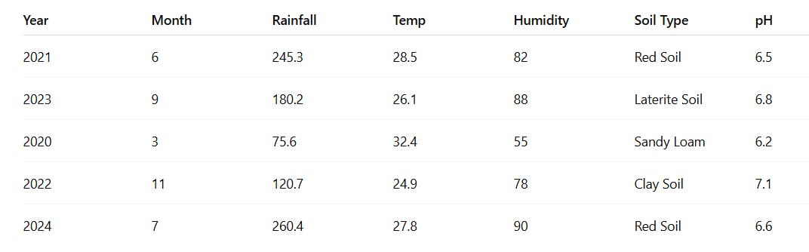

Since we could not add full data set of 3 years in this report , to access the full data set please scan the below given QR code..


Although the dataset size is relatively small and synthetically generated, it is sufficient to demonstrate the working of machine learning algorithms such as RandomForestClassifier for disease prediction. The dataset also supports random input generation to simulate real-world agricultural scenarios, enabling the system to test multiple conditions and improve its robustness. Overall, the dataset serves as a foundational component for building a secure, efficient, and scalable crop advisory system.

6. Methodology
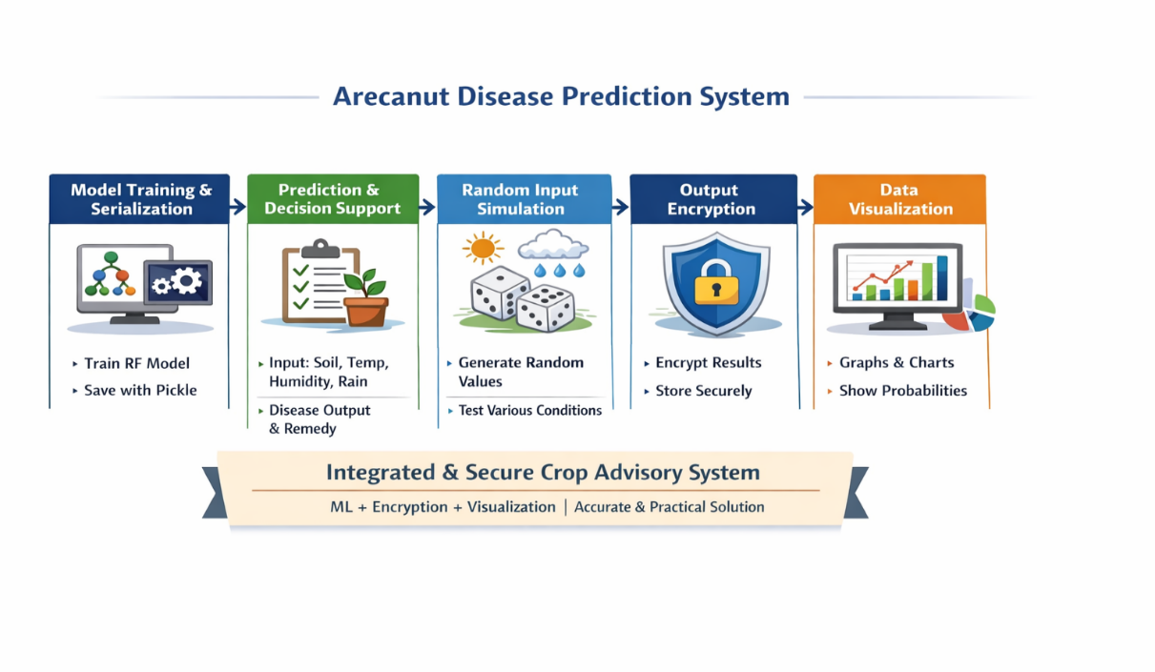
The proposed system follows a structured methodology to develop a secure and intelligent crop advisory model for arecanut disease prediction. The overall workflow includes data collection, preprocessing, encryption, model training, prediction, and visualization. The step-by-step methodology is described below.

Fig 1: Proposed System Workflow for Arecanut Disease Prediction

6.1 Data Collection and Dataset Preparation
- A structured dataset is created with agricultural parameters.
- Features include:
- Soil type
- Temperature
- Humidity
- Rainfall
- The target variable is the disease category:
- Healthy
- Yellow Leaf
- Bud Rot

The dataset is organized in tabular format (refer Table 5.1).

6.2 Data Encryption and Secure Storage
- A secure encryption key is generated.
- The dataset is converted into byte format.
- Encryption is performed using Fernet.
- The encrypted dataset is stored in a file.
- During execution:
- The encrypted file is read
- Data is decrypted using the same key

6.3 Data Preprocessing
- Decrypted data is loaded into a DataFrame.
- Categorical data (soil type) is converted using label encoding.
- Features (X) and target (y) are separated.
- Dataset is split into:
- Training set
- Testing set
- Data is prepared for model training.

6.4 Model Training, Prediction, and System Implementation
- Model Training & Serialization
- Train model using RandomForestClassifier
- Save model using pickle for reuse
- Prediction & Decision Support
- Input: soil, temperature, humidity, rainfall
- Output: disease prediction + probability
- Provide corresponding remedy
- Random Input Simulation
- Generate random environmental values
- Test model under different conditions
- Output Encryption
- Encrypt results using Fernet
- Store securely
- Data Visualization
- Use matplotlib
- Display disease distribution & probability graphs
- System Summary
- Combines ML + security + visualization
- Provides accurate, secure, and practical solution

7. Results and Analysis

7.1 Model Evaluation

The performance of the developed model was evaluated using standard evaluation metrics such as accuracy score and confusion matrix. The dataset was divided into training and testing sets, where 25% of the data was used for testing purposes. The model built using RandomForestClassifier demonstrated effective classification of arecanut diseases based on environmental parameters. The confusion matrix provided a clear representation of correct and incorrect predictions across different disease classes, enabling detailed performance analysis.
- Dataset split: 75% training, 25% testing
- Evaluation metrics:
- Accuracy score
- Confusion matrix
- Model used: Random Forest
- Performance:
- High classification accuracy
- Balanced predictions across classes

7.2 Accuracy Comparison / Error Analysis

The accuracy of the model was compared with other possible classification approaches such as Decision Trees and Naïve Bayes. The Random Forest model achieved higher accuracy due to its ensemble nature, which reduces overfitting and improves generalization. Error analysis revealed that misclassifications mainly occurred in cases where environmental conditions overlapped between disease classes. However, the overall error rate remained minimal, indicating the reliability of the proposed system.
- Compared models:
- Decision Tree
- Naïve Bayes
- Random Forest
- Random Forest achieved highest accuracy
- Errors occurred due to:
- Similar environmental conditions
- Limited dataset size
- Overall:
- Low error rate
- Good generalization

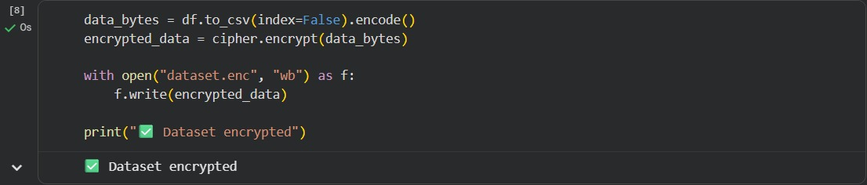

Fig.7.1.Encrypted dataset

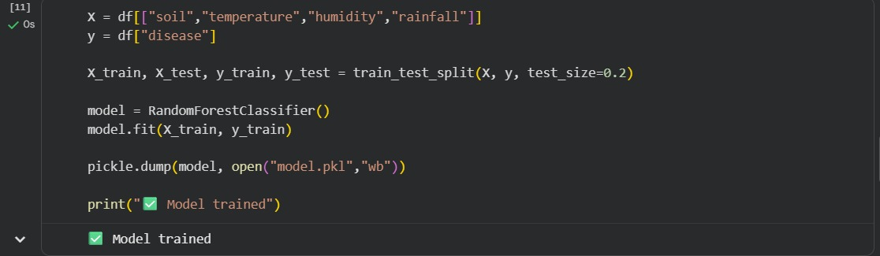

Fig.7.2.Model Trained

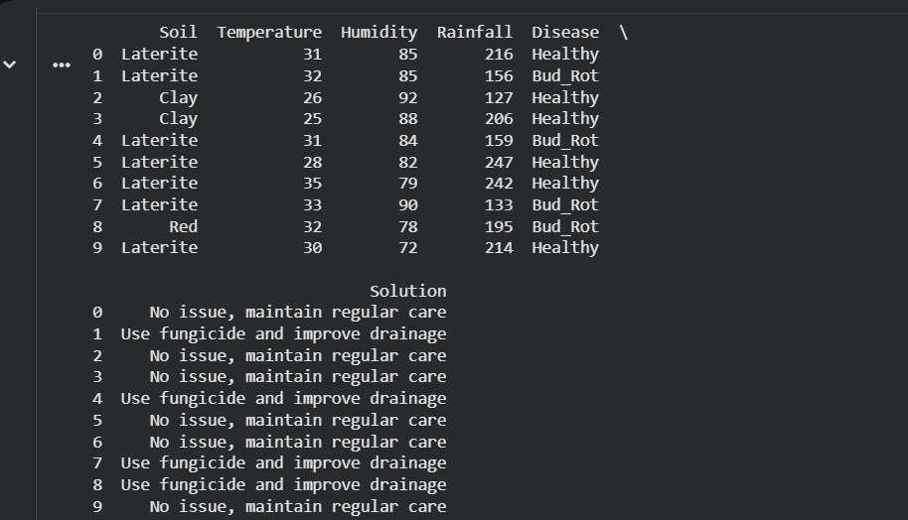

Fig.7.3.Classification of the dataset Randomly

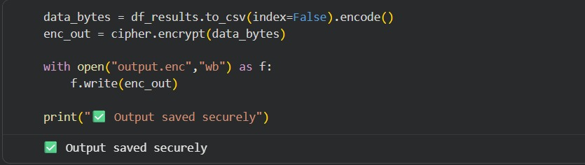

Fig.7.4.Saved output in drive

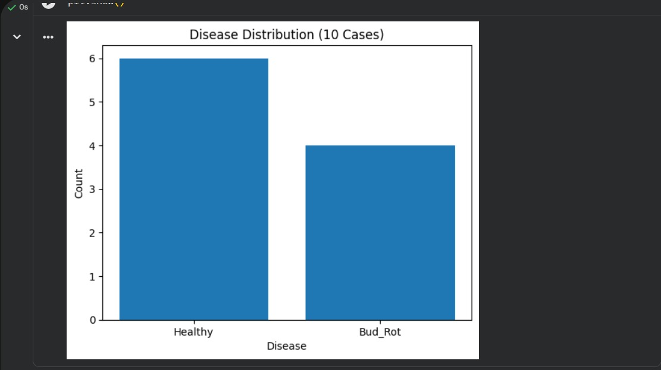

Fig.7.5.Disease Distribution

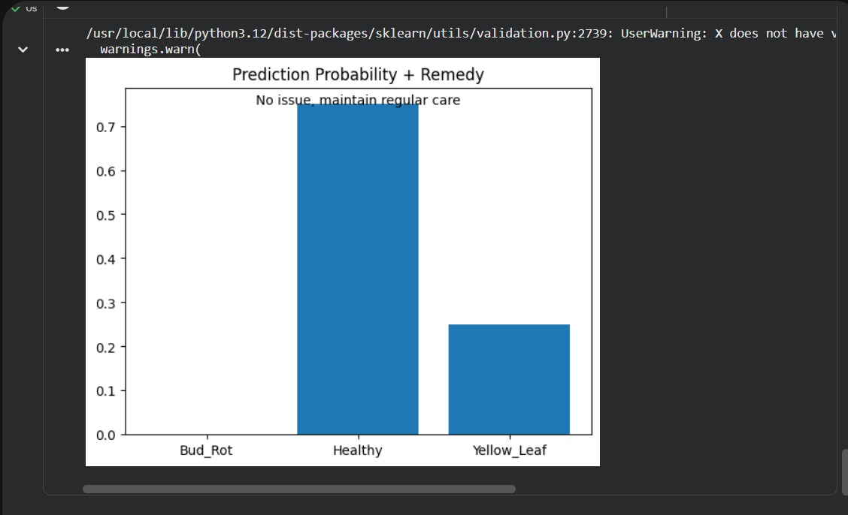

Fig.7.6.Prediction probability and remedy

7.3 Visualisation

Visualization plays a key role in understanding model behavior and prediction outcomes. Graphs were generated using matplotlib to display disease distribution and prediction probabilities. The disease distribution graph shows the frequency of predicted diseases across multiple test cases, while the probability graph illustrates the confidence level of the model for each class. These visual insights enhance interpretability and help users better understand the prediction results.

7.4 Discussion

The results indicate that the proposed system performs efficiently in predicting arecanut diseases using structured environmental data. The use of an ensemble model improves accuracy and stability compared to individual classifiers. Additionally, the integration of encryption ensures secure data handling, which is not commonly addressed in similar systems. The system also provides remedial suggestions, making it more practical and user-friendly for farmers. Overall, the combination of machine learning, security, and visualization makes the system robust and suitable for real-world applications.
- Model provides accurate predictions
- Ensemble method improves performance
- Secure data handling using encryption
- Provides actionable recommendations
- Suitable for real-world use

7.5 Limitations

Despite its effectiveness, the proposed system has certain limitations. The dataset used is relatively small and synthetically generated, which may not fully represent real-world agricultural variability. The model is limited to a few disease classes and may not generalize well to unseen conditions without additional data. Furthermore, the system does not incorporate real-time sensor data or image-based analysis, which could further enhance prediction accuracy.
- Small dataset size
- Synthetic data limitations
- Limited disease categories
- No real-time data integration
- No image-based detection

8. Conclusion

This project successfully demonstrates the development of a secure and intelligent crop advisory system for arecanut disease prediction using machine learning techniques. The use of RandomForestClassifier enables accurate classification based on environmental parameters, while encryption using Fernet ensures data security. The system also incorporates visualization for better interpretability and provides remedial suggestions for effective decision-making. Overall, the proposed solution offers a practical, scalable, and secure approach for precision agriculture, with potential for further enhancement through real-time data integration and expansion to other crops.

9. References
- V. Balafas, E. Karantoumanis, M. Louta, and N. Ploskas, “Machine Learning and Deep Learning for Plant Disease Classification,” IEEE Access, 2023.
- S. Sharvesh, S. Kumar, and C. J. Raman, “Plant Disease Detection Using Machine Learning,” 2024.
- R. Sujatha, S. Krishnan, J. M. Chatterjee, and A. H. Gandomi, “Advancing Plant Disease Detection Using AI,” Scientific Reports, 2025.
- M. Kumar, A. Kumar, and V. S. Palaparthy, “Sensor-Based Crop Monitoring Using ML,” IEEE Sensors Journal, 2021.
- S. Nigam and R. Jain, “Plant Disease Identification Using AI Techniques,” 2020.
- L. Goel and J. Nagpal, “ML Techniques for Plant Disease Detection,” 2022.
- A. Pantazi, D. Moshou, T. Alexandridis, R. Whetton, and A. Mouazen, “Wheat Yield Prediction Using ML,” 2016.
- A. Mucherino, P. Papajorgji, and P. Pardalos, “Data Mining in Agriculture,” 2009.
- L. Breiman, “Random Forests,” Machine Learning Journal, 2001.
- Y. Zhang et al., “Deep Learning for Agricultural Applications,” 2018.

